**Experiment 1**

**Aim –** To generate a random number upto 100 and print weather its prime or not

**Theory–**

**Step 1 :**go to new file

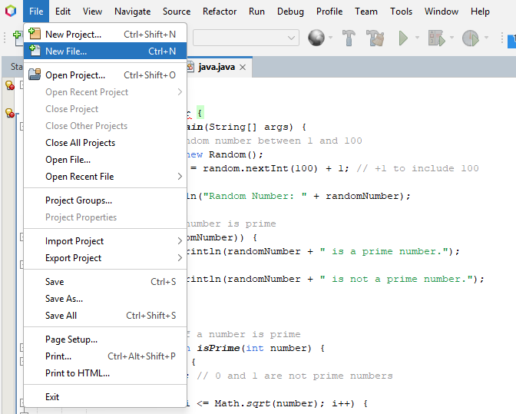

**Step 2 :** choosing the file format

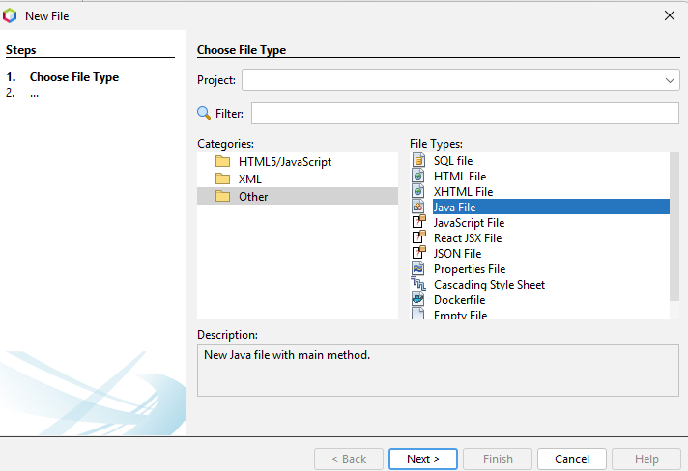

**Step 3 :** Naming of the file

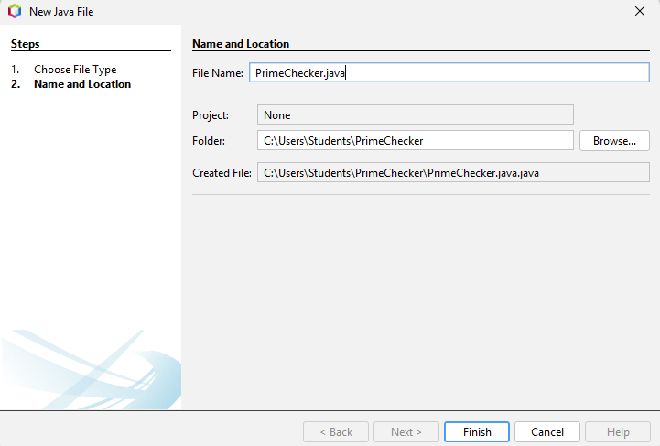

**package** govind;

**import** java.util.Random;

**public** **class** random{

**public** **static** **void** main(String[] args) {

Random x = **new** Random();

**int** a = x.nextInt(100);

System.***out***.println("Random number is: " + a);

**if** (a <= 1) {

System.***out***.println("not prime");

**return**;

}

**for** (**int** i = 2; i <= Math.*sqrt*(a); i++) {

**if** (a % i == 0) {

System.***out***.println("Not prime");

**return**;

}

}

System.***out***.println("It is prime");

}

}

**Output:**

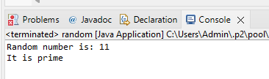

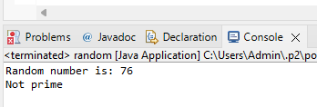

**Learning Outcome:**